Monday, November 9, 2020
Dear [Recipient’s Name],
Welcome to the UAMS AHEC Scholars program! Your interest in this program demonstrates your commitment to improving the health of rural and underserved communities in Arkansas. As you meet the program requirements and receive UAMS AHEC Scholars recognition, you become part of a national network of AHEC Scholars. This achievement should serve to make you even more competitive with future training programs and employers.
Many of the clinical hours and courses that you are already planning to complete (or have completed) will help you to fulfill the requirements of the AHEC Scholars program. Throughout the next few semesters, please remember to refer to both the AHEC Scholars Handbook and the AHEC Scholars Program Plan for guidance. In addition, program staff will be contacting you periodically to help ensure you are meeting program requirements and to answer any questions.
The UAMS AHEC Scholars program aims to produce healthcare providers who are well trained and suited not only for a rapidly changing healthcare environment, but also for the unique challenges faced by health care providers in rural and underserved communities. The work that you will complete as a part of this program will focus on six key topics: Interprofessional Education, Behavioral Health Integration, Social Determinants of Health, Cultural Competence, Quality Improvement, Practice Transformation, and Current & Emerging Health Issues. As you plan your career in health care, the knowledge, skills and abilities gained through the AHEC Scholars program will strengthen your capacity to become a leader and change agent in your future practice as a health professional.

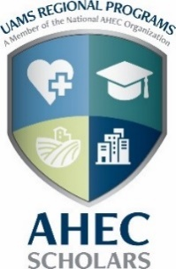
We look forward to working with you,
Leslie Stone, MD
AHEC Scholars Medical Director
UAMS Regional Programs and Family Medicine

